Steps to create a Vagrant file!

**To setup a VM (Vagrant file)**

* Download and Install Git……. You need the git CLI
* Visit <https://app.vagrantup.com/boxes/search> and select a vagrant file
* Create a folder in a directory, you can name it “vagrant-vms”…….. mkdir vagrant-vms
* Open the Git CLI and type 🡺
* cd /c/vagrant-vms
* vagrant init ubuntu/trusty64 (the box name from the cloud)

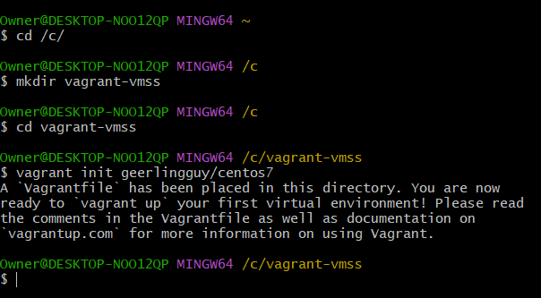

* vim vagrantfile …… to adjust the Ram --- uncomment line 52 to 58 and adjust the ram & add C.P.U ---- “vb.cpus = 2”, uncomment the public network to get an I.P from the bridge adapter, uncomment the private network also.

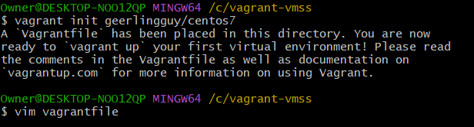

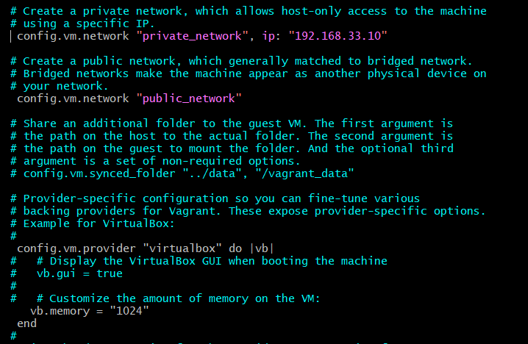

* vagrant up
* vagrant ssh
* cd /vagrant/ …. To syn directories to protect your files
* sudo –i ……………. For root
* logout
* vagrant halt ………….. for vagrant shutdown

Next study area: Check Provisioning a Vagrant file! (provisioning(Vagrant file!)